This is a Take-Home Exam. You are allowed to use the lecture notes of this course, your own notes, and the course book(s). It is very important that you write down all your explanations and arguments. You will still earn partial credit if your arguments are correct, but your equations are not.

You sign here to indicate that you did not give, or receive any help from others: ______________

# Due date/time: May 7th at 5pm

Introduction to Space Plasma Physics, Phys 712/812

## 1) Types of Solar Wind: (5 points)

Fast solar wind:

1. What types of regions on the sun are the source of the fast wind?
2. What is the magnetic field line configuration in these regions?
3. Where are the regions mainly located during solar minimum?

Slow solar wind:

* 1. What is the typical density of the slow solar wind?
  2. What is the topology of the magnetic field lines in regions where the slow solar wind is emitted?
  3. Where are these regions mainly located during solar minimum?

## 2) Solar Magnetic Field: (5 points)

1. Describe in sketches and words how the solar magnetic field changes during a solar cycle.
2. Explain why sunspots come in pairs with opposite polarity, and why the polarities are reversed in the two solar hemispheres.

## 3) Interplanetary Disturbances: (10 points)

1. Explain why the magnetic field in interplanetary space has a "Parker spiral" configuration.
2. If the solar wind velocity is faster, how does that change the spiral?
3. Explain how stream interaction regions are formed? (Please use a sketch, if necessary).

## 4) The solar corona in hydrostatic equilibrium: (20 points)

The hot corona (T~106 K) far above the Sun’s surface the temperature drops off slowly with increasing distance.

$T\left(r\right)=To{\left(\frac{r_{0}}{r}\right)}^{2/7}$

where 𝑟& is a base radius in the corona, often assumed to be about 2 𝑅⊙ (Solar radius), and 𝑇& is the temperature at the base radius.

Assuming a corona with no fluid flow (i.e., u = 0 everywhere) in spherical symmetry, write the equation of hydrostatic equilibrium and show that it can be simplified into the form:

$\frac{ⅆ}{ⅆr}\left(\frac{ρ}{r^{2/7}}\right)=-C_{1}\frac{ρ}{r^{2}}$

and give an expression for the constant 𝐶4in terms of the solar mass, the properties at𝒓𝟎, and other physical constants.

(Hint: Start with a spherical symmetry and the equation of hydrostatic equilibrium i.e. the gradient of the thermal pressure balances the gravitational force. Assume an ideal gas)

## 5) Magnetic reconnection: (10 points)

Reconnection Models

Make sketches of the following reconnections models and indicate the following important parameters: Inflow, outflow, and diffusion region for:

* Sweet Parker
* Petschek
* And the so-called “Hall reconnection” model

Describe the basic differences

**6) Geomagnetic activity (10 points)**

Describe the differences between a geomagnetic storm and a substorm.

## 7) Magnetosphere and ionosphere currents (15 points)

Draw and label the major magnetosphere and ionosphere current systems on the following figures. Use the standard symbols (V,) for currents into and out of the page and arrows for those in the plane of the page.

|  |  |
| --- | --- |
|  |  |

## 8) Inner magnetosphere particle drifts (25 points)

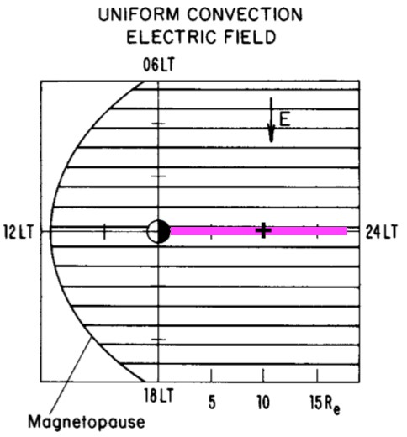The drift path of a charged particle in the inner magnetosphere is dictated by the vector sum of the drift velocities caused by (1) gradient/curvature drift and ExB drift due to both the (2) convection and (3) corotation electric fields.

Answer the following questions for a particle with 𝛼eq = 90° in the magnetic equator and the midnight local time meridian (purple line in the figure). Assume that the convection electric field is as shown in the figure and that the Earth’s magnetic field is a dipole.

W. D. Cramer/H. Kucharek Final Exam Spring 2020

1. Draw the direction of the drift velocity vectors associated with (1)-(3) listed above at the "+" sign on the figure (at L=10).

1. Calculate the particle energy required as a function of L-shell, W(L), for the net velocity of the particle to be pointed directly earthward. (Hint: the contribution of one of (1)-(3) can be ignored)

1. Would it be possible for this particle to drift directly earthward along the midnight meridian from L=15 to L=5 under purely adiabatic conditions? Explain.